Income Classification Using the k-Nearest Neighbor Model

Allen Gao
University of Massachusetts Amherst
MIE622
Michael Prokle
Introduction
This report evaluates whether a k-nearest-neighbors classification model could be adopted by organizations to identify patterns associated with low- and high-income individuals. Using the data from the adult-all CSV, the model classifies the individuals into two groups: those earning $50,000 or less per year and those earning more than $50,000 per year. The datasets include demographic, educational, and employment-related variables such as age, occupation, and hours worked per week.
Before considering the KNN model, the CSV data must be properly cleaned, as several values are missing for some data points. If missing data aren’t fixed, it could lead to the model not being able to properly classify the citizens as either low- or high-income, which produces less reliable income classifications. Therefore, the data-cleaning process is necessary to improve the consistency of the dataset and ensure that the k-nearest-neighbors model is trained using high-quality information.
Data Cleaning
To begin the data-cleaning process, the column names were standardized by removing unnecessary spaces and converting all letters to lowercase. Extra spaces were also removed from the categorical values. This prevents the values representing the same category from being treated as different categories due to inconsistent formatting. The dataset is then examined to check to see if there are any duplicate observations. Any exact duplicate records were removed because repeated observations could give certain individuals more influence on the classification model and potentially affect its accuracy. Duplicate detection was performed before dropping any variables because removing columns first could cause two originally different observations to appear identical. Checking for duplicates while all original variables were still present helped ensure that only truly duplicated records were deleted.
Two variables/columns were removed from the datasets, which were the fnlwgt and the education. The fnlwgt variable seems to represent the census sampling weight that was assigned to each observation, rather than a direct characteristic of the individual. Because we are trying to predict the income for each observation using a person’s characteristics, the fnlwgt is not included as a predictor because it doesn’t seem to describe the individual’s actual attributes. The education variable was removed because the same information was already represented numerically by the education-num variable. Although k-nearest neighbors cannot directly process categorical text, the education variable could have been converted into numerical dummy variables through one-hot encoding. However, keeping both variables would have represented education twice and could have given educational attainment too much influence in the model’s distance calculations. Therefore, the categorical education variable was removed while the numerical education-num variable was retained.
Once that was done, all the question marks that appeared throughout the datasets were replaced with recognized missing values, represented as NaN. The question marks indicated that information was unavailable, but they were originally stored as text and could not be handled correctly by the model. Converting them to NaN would allow people to identify missing entries and apply the appropriate replacement methods. For the categorical variables workclass, occupation, and native-country, the missing values with NaN were replaced with mode, a function that returns the most frequently occurring category within each variable. The mode was appropriate as those variables contained categorical rather than numerical data. This was done to preserve observations with missing information instead of removing them from the dataset, which would have reduced the amount of data available for training the model. Once done, we also did something similar with the numeric columns, where it would replace any data that had NaN with the median of the corresponding variables, such as age, capital gain, and capital loss.
Once we had replaced all of the missing data with usable data, the income labels were converted into numerical values so they could be processed more easily by the classification model. Individuals earning $50,000 or less per year were assigned a value of 0, while others earning more than $50,000 per year were assigned a value of 1. This also allows the k-nearest neighbor model to distinguish between low- and high-income categories during training and prediction.
Building the KNN model
After the data-cleaning process was completed, the census variables were separated from the income labels because the census variables served as the predictors and the income label served as the outcome being predicted. The row indices were then randomly shuffled before the data were divided into 70% training data and 30% testing data. The corresponding income labels were divided using the same indices to ensure that each observation remained matched with its correct outcome. This process helped prevent the original row order from influencing how observations were assigned to each set. After the training and test datasets are all set up, they go through the preprocessing pipeline. The categorical variables were converted into numerical dummy variables through one-hot encoding because k-nearest-neighbors algorithms cannot calculate distances using text-based categories. The numerical variables were standardized so that they were measured on comparable scales. That step is important because variables with larger numerical ranges could have excessive influence on the distance calculations, so it reduces the likelihood that large values in the measurement units would distort the identification of the nearest observations.
To determine the appropriate value of k, the model used GridSearchCV to compare several candidate values: 3, 4, 5, 7, 9, 11, 15, and 21. The range was intentionally limited because testing a large number of values required a substantial computation time. For each candidate value, the k-nearest neighbors classifier was evaluated using three-fold cross-validation. Accuracy was used as the evaluation measure, and the average validation accuracy was calculated for each value of k. The value with the highest average cross-validation accuracy was then used in the final KNN model to classify observations in the testing dataset. The predicted income labels were compared with the actual labels to calculate the model’s final test accuracy.
Results
After the model was prepared, GridSearchCV found that K=21 produced the highest average cross-validation accuracy among the candidate values tested. The model achieved a cross-validation accuracy of 84.51%, indicating that it correctly classified approximately 85% of the validation observations during the three-fold evaluation. Therefore, K=21 was selected for the final k-nearest-neighbors function. The selected model was then applied to the testing dataset to predict each individual’s income classification and was compared with the actual income label. The final model achieved a test accuracy of 84.85%, which was close to its cross-validation accuracy of 84.51%. This similarity suggests that the model generalized well to unseen data and did not experience a substantial decline in performance outside the training process.
After evaluating the model’s accuracy, the distribution of the income categories in the cleaned dataset was displayed using a bar chart where 0 and 1 indicate low- and high-income citizens. As shown in Figure A1, there are substantially more low-income observations than high-income observations, indicating an imbalance between the two classes. This imbalance is important when interpreting model accuracy because a model could achieve a relatively high accuracy by favoring the more common low-income category.
Also, in Figure A2, high-income observations were more concentrated among middle-aged individuals, particularly between approximately 35 and 55 years old, while low-income observations were more common among younger individuals and were distributed across a wider age range. However, the taller low-income bars also reflect the substantially larger number of low-income observations in the dataset, consistent with the class imbalance shown in Figure A1. Similar relationships may exist for variables such as education level and hours worked per week. The class imbalance may have contributed to the overall accuracy, but it cannot be concluded that the imbalance alone caused the model to achieve approximately 85% accuracy. The result should also be compared with a baseline model that always predicts the majority low-income class.
Overall, the k-nearest-neighbors model showed that census variables could be used to classify individuals into low- and high-income groups with a test accuracy of 84.85%. The use of data cleaning, one-hot encoding, numerical standardization, and cross-validation helped improve the reliability of the model. GridSearchCV selected K=21 because it produced the highest average cross-validation accuracy among the values tested. However, the results should be interpreted carefully because the dataset contained substantially more low-income observations than high-income observations, which may have influenced the overall accuracy. The KNN should be used with caution for studying income patterns.
Appendix
Figure A1
Distribution of Income Categories
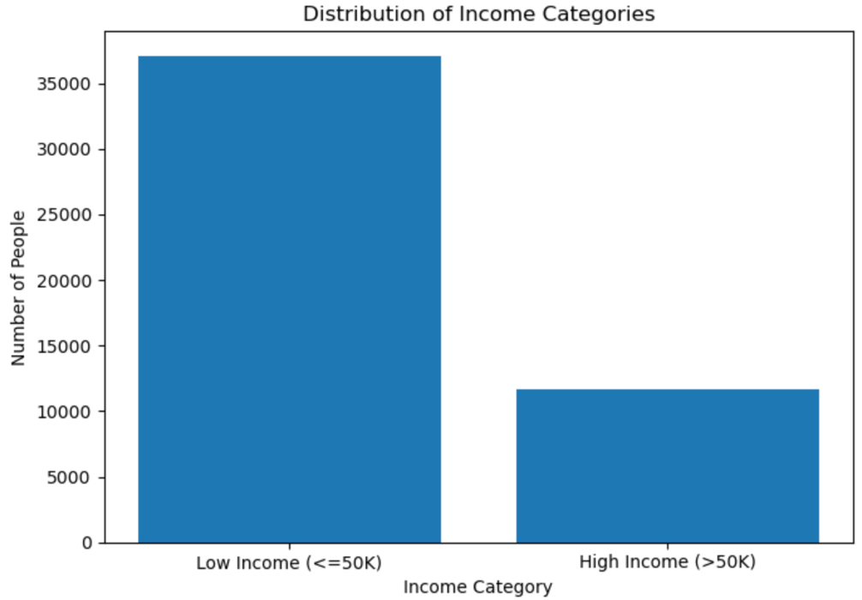
Note. Low income represents annual earnings of $50,000 or less; high income represents annual earnings above $50,000.
Figure A2
Age Distribution by Income Category
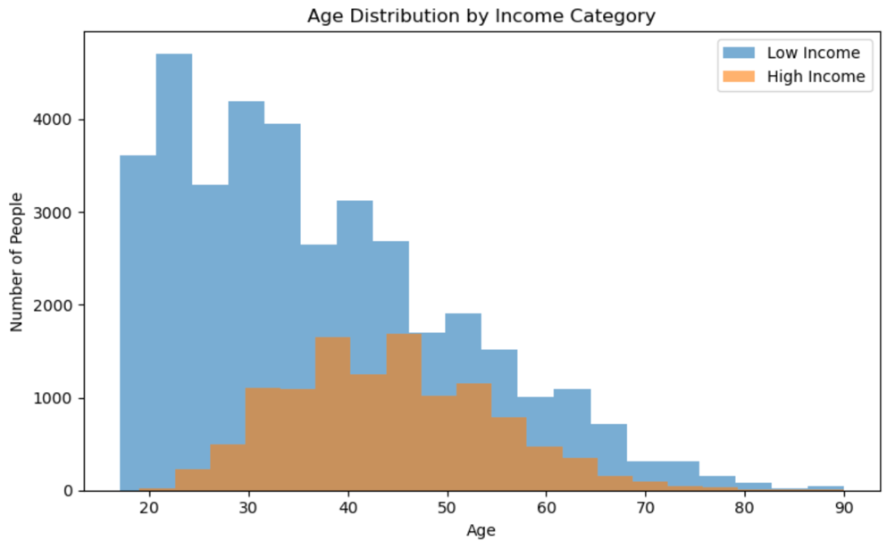
Note. Low income represents annual earnings of $50,000 or less, and high income represents annual earnings above $50,000.

